

**Hello! This is Click Sensor Hub.**

**Senior Design Team:**

**Alfonso de la Morena- Dylan Dean – Mohamed Sghari**

Take the comments off, change colors, fix button links, create images, and demo video*

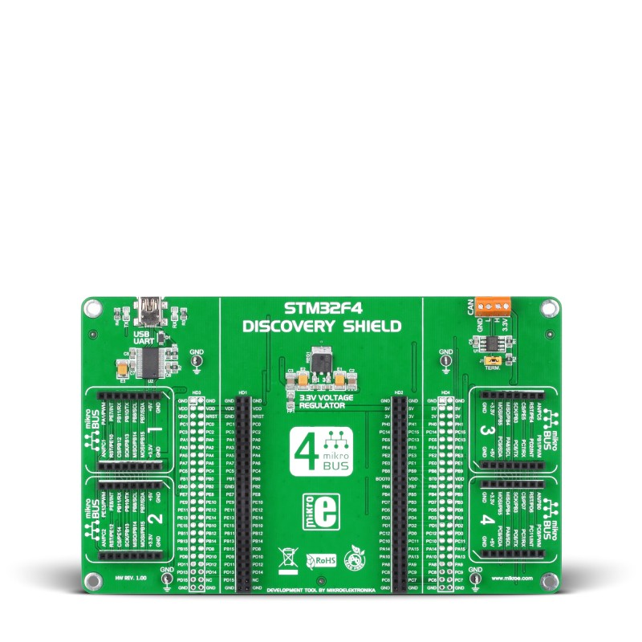

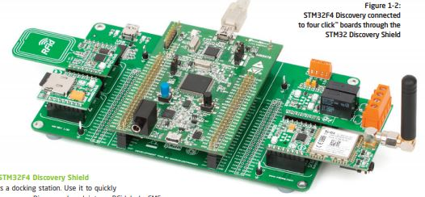

WE HELP YOU CREATE MODERN IoT PROJECTS

Click Sensor Hub is a one-sided board extension designed around the FRDM-KL46Z development platform. The board incorporates the industry accepted mikroBUS standard. User friendly design, simply plug-in sensors answer the prompts and begin prototyping your projects.

Continue Reading…leads you to user guide and basic product description.

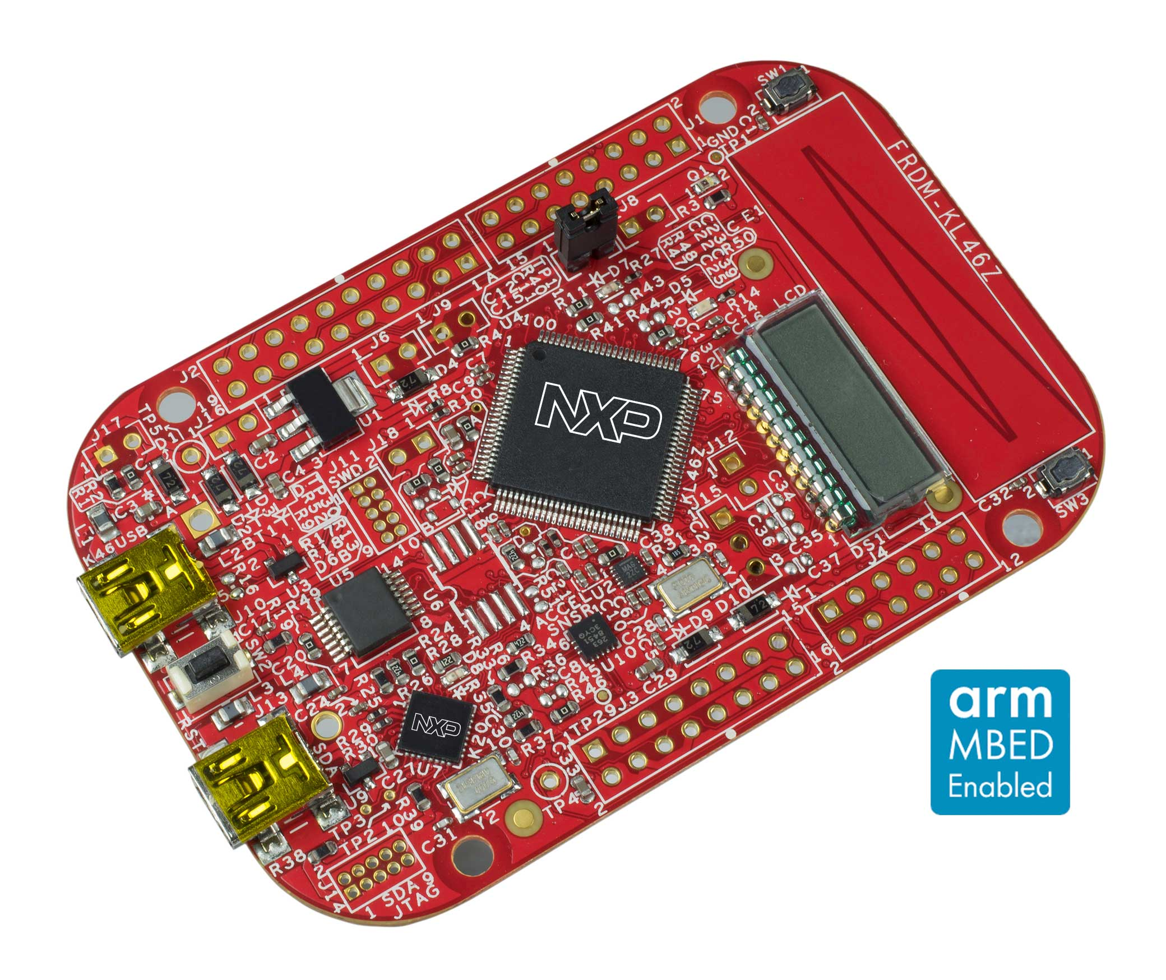

WHAT IS THE FRDM-KL46Z?

Pull from NXP description and give some background text as to why it is the processor of choice.

Continue Reading… takes you to NXP Link for their platform.

[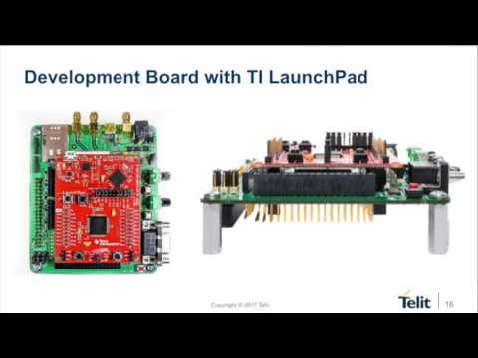](https://www.youtube.com/watch?v=7Pnkgqe_YwI)

INTRODUCING OUR RAPID IoT DEVELOPMENT PLATFORM—DEMO VIDEO HERE

Enjoy this brief demo video showing the capabilities of our board in an IoT environment.

Continue Reading… Mo needs to type a little description of the PCB hardware and layout.



BEST OF ALL WE ARE MAKING EVERYTHING OPEN SOURCE!

The Click Sensor Hub design process and all coding has been documented extensively. We want to share our journey with you. We hope that in doing so you can make suggestions for improvements and the development platform will continue to grow.

Continue Reading…takes you to our source files and relevant links.